**Nerd Essay Portal Issues: 14-05, 15-05, 16-05**

# Functionality Issues:

## Func_01

File upload issue.

**Steps to Reproduce:**

1. Start to place an order.
2. Navigate to the file uploading section.
3. Upload one or more files.
4. Delete these files on the very page.
5. Upload exact same file(s) again.

The same file(s) cannot be uploaded.

## Func_02

Notification issue.

1. Place, order, and use the “pay only 25%” payment method.
2. The order is placed successfully.
3. Now, pay the remaining amount.

**The user does not receive a notification for the transaction of the remaining amount.**

## Func_03

Email issue.

1. Place, order, and use the “pay 25%” payment method.
2. The order is placed successfully.

**However, the user does not receive an email about the order placement.**

## Func_04

Email issue.

1. Place, order, and go for the full payment method.
2. The order is placed successfully.

**However, the user does not receive an email for the order placement.**

## Func_05

Deadline field issue.

1. Start to place an order.
2. Select deadline category, “More than 24hrs”.
3. Now, in the deadline field, the automatically fed time is 6 hours past the present time.

**Recommended: The deadline should either be the present time, or to make it more user-friendly, the deadline should be “25 hours” from the present time.**

## Func_06

Order Chat’s refresh button.

1. Place an order.
2. The chat refresh button is there.
3. Now, start a chat.
4. The chat refresh button vanishes.

# DEADLINE ISSUES: (Time and region changed to Canada)

## Func_07

1. Select “Less than 12 hours”, deadline category.
2. Further, select “12 hours”.
3. Go for partial payment.
4. The deadline is incorrect and inconsistent in the sections mentioned below.
   1. Deadline selection page.
   2. Order success page.
   3. Order details in “In Progress”, page.
   4. “Full payment received”, email.

## Func_08

1. Select “Less than 12 hours”, deadline category.
2. Further, select “6 hours”.
3. Go for partial payment.
4. The deadline is incorrect in the section mentioned below.
   1. Deadline selection page.

## Func_09

1. Select “12-24 hours”, deadline category.
2. Further, select “13 hours”.
3. Go for full payment.
4. The deadline is incorrect and inconsistent in the sections mentioned below.
   1. Deadline selection page.
   2. Order success page.
   3. Order details in “In Progress”, page.

## Func_10

1. Select “12-24 hours”, deadline category.
2. Further, select “24 hours”.
3. Go for partial payment.
4. The deadline is incorrect in the section mentioned below.
   1. Deadline selection page.

## Func_11

The deadline in the “writer assigned” email is incorrect.

## Func_12

The deadline field is not sustainable.

1. Start placing an order.
2. Select a deadline of more than 24 hours.
3. Choose the Stripe payment method.
4. Once navigated to the Stripe transaction page, go back.
5. Go back to the deadline page.
6. The deadline in the order summary remains as selected.

**However, the deadline field – Calendar field – does not sustain the selected deadline.**

# UI / UX:

## UI_01

**Steps to Reproduce:**

1. Click “Forgot Password”.
2. A password email is sent to the user. In this email, click the “Reset Password” button.
3. This button redirects to the “Password Reset” page, where the user can enter a new password.
4. On this page, there is a message **-** “**We sent a link to** [**nahmad0313@gmail.com**](mailto:nahmad0313@gmail.com)**” -** above the input fields.
5. This message is unnecessary.

**Screenshot:**

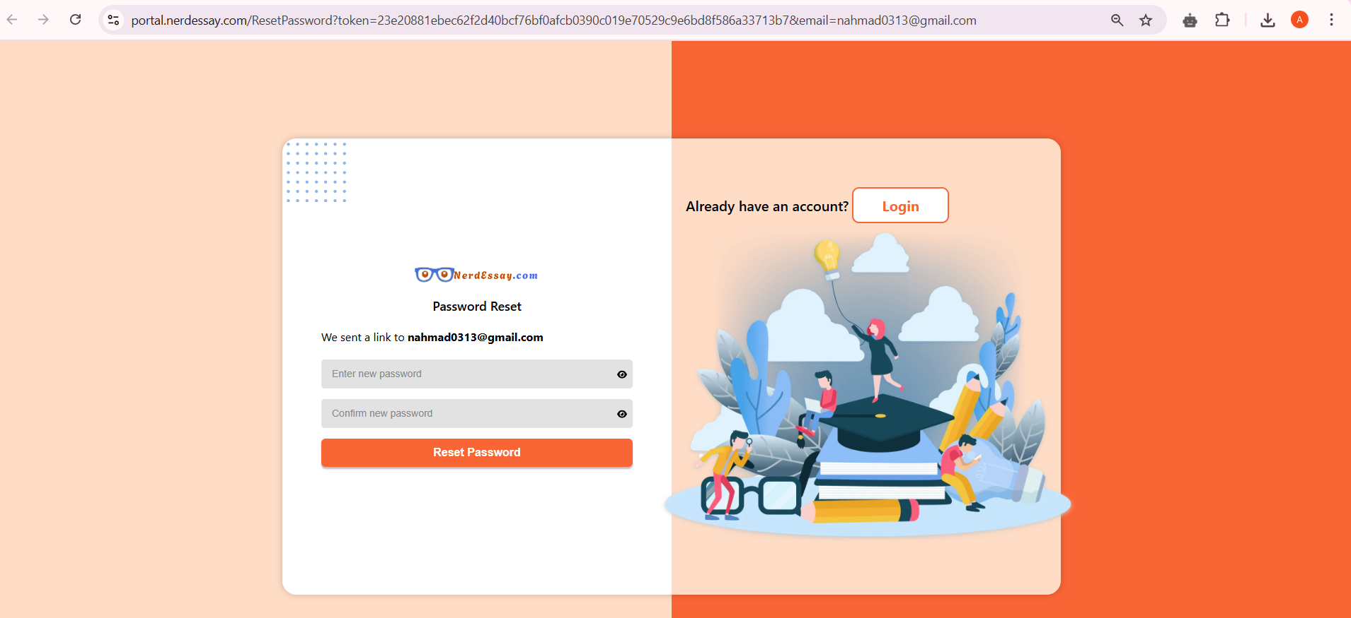

## UI_02

Referral page color inconsistency.

**Screenshot:**

